**KEY SHELL COMMANDS**

* **echo- to print something**
* **cat- to show the contents of the file**
* **tail- to show the last line of a file**
* **grep- search for words in a file**
* **systemctl- to start/stop/restart services**
* **chmod- to change permissions**
* **awk- extract specific fields from logs**
* **tail- to view the last part of file**
* **cut- used to cut sections of each line based on delimeters**

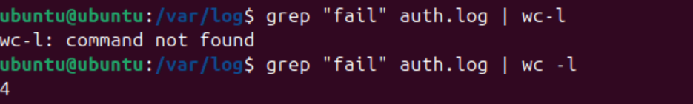**TROUBLE SHOOTING**

Here, error comes due to lack of space between wc and - .  
grep “fail” log file is used to find count of failed entries.  
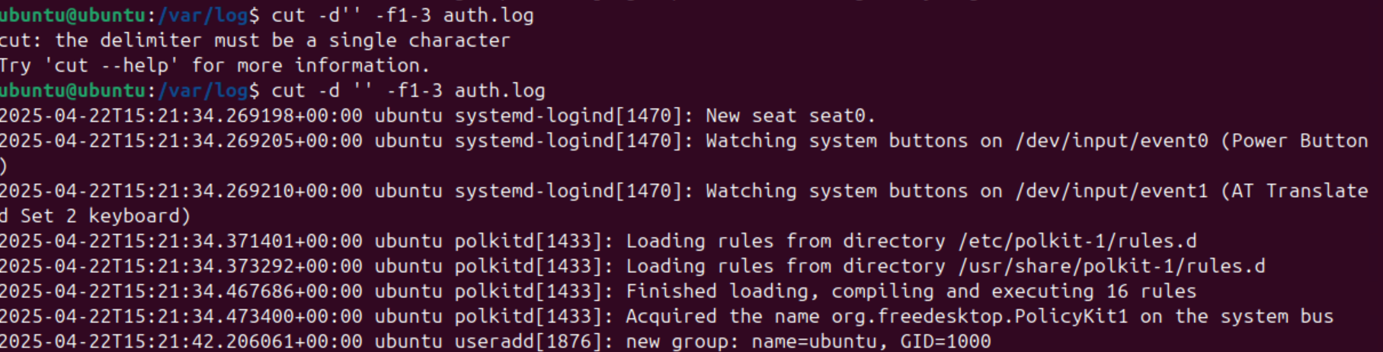

Here, error comes due to lack of space between d and ‘ ’

cut -d ‘ ’ -f1-3 log file command is used to get first 3 fields from that particular log file.